Everyone is now required to create their profile themselves in order to be featured on the website.

In order to create your profile you need an automatically generated email from the Wordpress blog site, if you are not currently in your first year of study you will have received this email in late August/early September. This email cannot be resent so please try and find it in your inbox.

If you are in your first year in IRES please let the staff know and they will send you a link.

If you can’t find the email, or if you have logged in before you can access your profile by following this link: www.ires.ubc.ca/wp-admin

In all cases this will take you to a CWL login page.

Once you log in select from the Dashboard on the left hand side “Profiles” and under that select “Your Public Profile.” It should look like this:

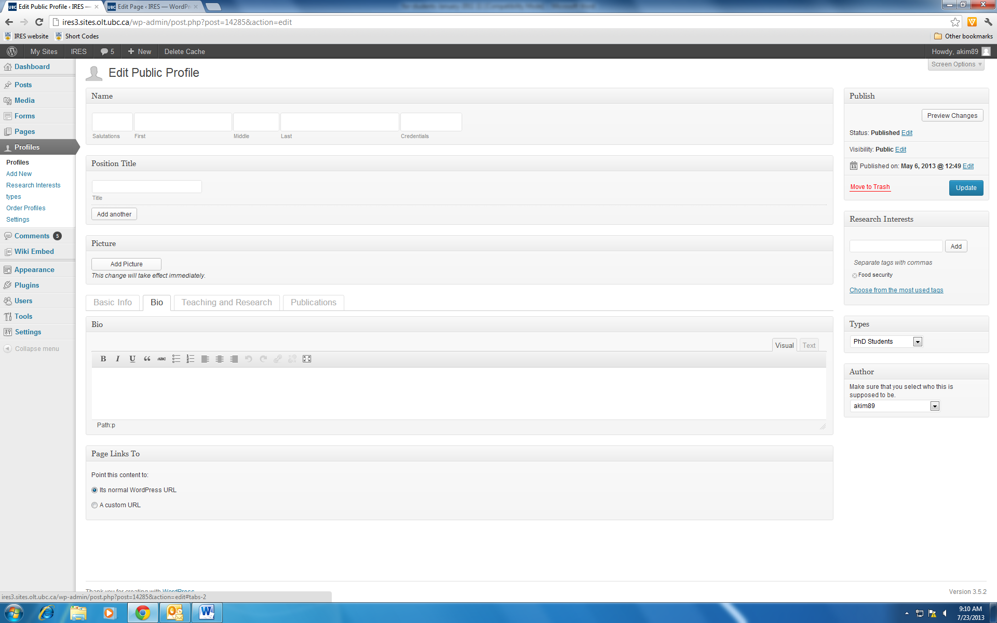

Please make sure that you fill in:
- First and last name
- Bio under the second tab
- Types: i.e. PhD Student, MA Student, MSc Student in the drop down box
- Your picture

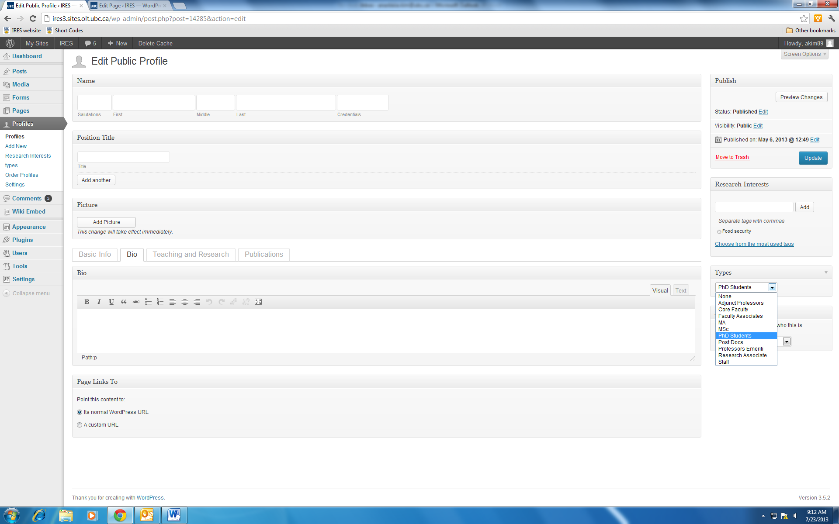

If you have any questions please come into office 427 for further assistance, it should take around 10 minutes.

