Visualizing Climate Change

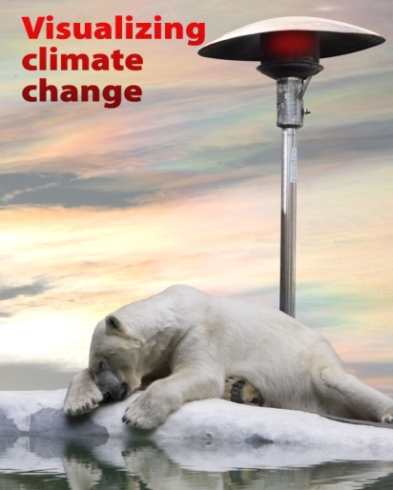
This course provides an introduction to climate change through the lens of BC landscapes and local communities. It uses visual media such as 3D visualisation and other interactive learning tools to explain current realities and possible futures with climate change. It aims to build awareness about what climate change means for communities and the environment, how people perceive it, and how we ourselves can engage other people on climate solutions.
Graduate Teaching Assistants
Course No.: CONS 210 - Term 1 | Instructor: Stephen Sheppard
Course Name: Visualizing Climate Change | Total No. Required: 2-3 GTA
Required Qualifications:
- Graduate Student (preferable PhD candidate) and/or experience in climate change, landscape planning, visual media, and/or communications.
- Excellent verbal and written skills
- Strong organizational skills
- Preferable previous TA experience, including I-Clickers and Connect web platform
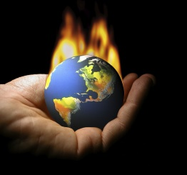
Description of General Nature of Duties:
- Co-ordinate field trips, assignments, and references.
- Run tutorial for students on climate change communication plans.
- Assist in student project supervision/coordination.
- Grading assignments and midterm.
- Coordinate class website and student communications.
Hours Allotted: 6-9 hours work per week for 16 weeks depending on budget and enrolment
Apply directly by e-mail or in person:

FRM.Recept@ubc.ca
Heather Akai/Scheyla Weiss
Forest Resources Management
2045- 2424 Main Mall, Vancouver BC V6T 1Z4

